Milestone 2 — Orchestration & Workflow Design
Business Account Data Enrichment Pipeline — Client Pilot, Athens, Georgia Mourya Bekkanur Dinesh — Sole Contributor

1. Updated Scope and Changes Since Milestone 1

1.1 Workflow and outcome
The pipeline enriches sparse business account records for a Client pilot covering 50 Athens, Georgia accounts, populating up to 14 required fields from multiple sources in priority order. The primary user is the data analyst who reviews and approves low-confidence field candidates before they are written to the account record. The measurable outcome is field completeness rate: the proportion of the 14 required fields populated at or above the confidence threshold after one full pipeline run, compared against the before-enrichment baseline.

1.2 Implemented for Milestone 2
For Milestone 2, I implemented the core pipeline in Python against a local SQLite database (enrichment.db). The following components are implemented and running:
- Database schema (db.py): all five tables created and queryable
- Account import (import_accounts.py): reads the 50-account Athens xlsx into the accounts table
- Mock extractors (mock_data.py): deterministic fixtures for all stages, used in tests
- Pipeline orchestrator (pipeline.py): all 7 stages execute in sequence with SQLite checkpoints after each stage
- Confidence gate: auto-applies fields at or above threshold; routes below-threshold fields to review_queue
- Claude extraction passes (claude_client.py): Stages 3, 5, 6, and 7 call claude-sonnet-4-6 via the Anthropic API when ANTHROPIC_API_KEY is set
- Test suite (test_m3.py): 5 tests covering the successful path, low-confidence routing, legal field lock, no-site fallback, and API unavailability
Stage 1 (GA SOS eCorp lookup) uses a mock HTTP response for all tests. The reviewer CLI and event trigger (poll_events.py, resume.py, reviewer_cli.py) are designed and partially scaffolded but are fully implemented (completed after M2 submission); those are the primary additions for Milestone 3.

1.3 Changes since Milestone 1
The Milestone 1 architecture referenced Salesforce as the write destination. After reviewing the pilot constraints, I dropped Salesforce entirely. SQLite is now the system of record for both account data and all pipeline state. This simplifies the prototype significantly, removes the need for external credentials, and makes the full pipeline runnable locally with a single command. The design decision table in Section 5 records this change with rationale.
The confidence threshold is defined in config.py and defaults to 0.80. This value was chosen based on initial extraction runs described in Section 5; it is not hardcoded and can be adjusted without touching pipeline logic.

2. Detailed Orchestration Workflow

2.1 Control model
The workflow is controlled by ordinary Python code in a fixed sequence with explicit conditional branches. No agent chooses among tools and no orchestration framework is used. The fixed sequence fits this pipeline because the order of data sources is determined by reliability and cost: authoritative legal data must come from the SOS registry before any model call; website evidence must be fetched before Claude can read it. The only variable paths are the branch after Stage 3 (no site accepted → skip Stage 4) and the branch at the confidence gate (auto-apply vs review queue).

2.2 Trigger and execution sequence
A run starts when run_pipeline(account_id, run_id) is called, either directly or via poll_events(). The trigger is a row in the pending_events table with processed = 0. The orchestrator reads the account from the accounts table and runs stages 1 through 7 in order. After each stage completes, it writes the stage number and a stage_complete event to SQLite before proceeding. If the process is interrupted, resume_run(run_id) reads the last completed stage and continues from the next one.
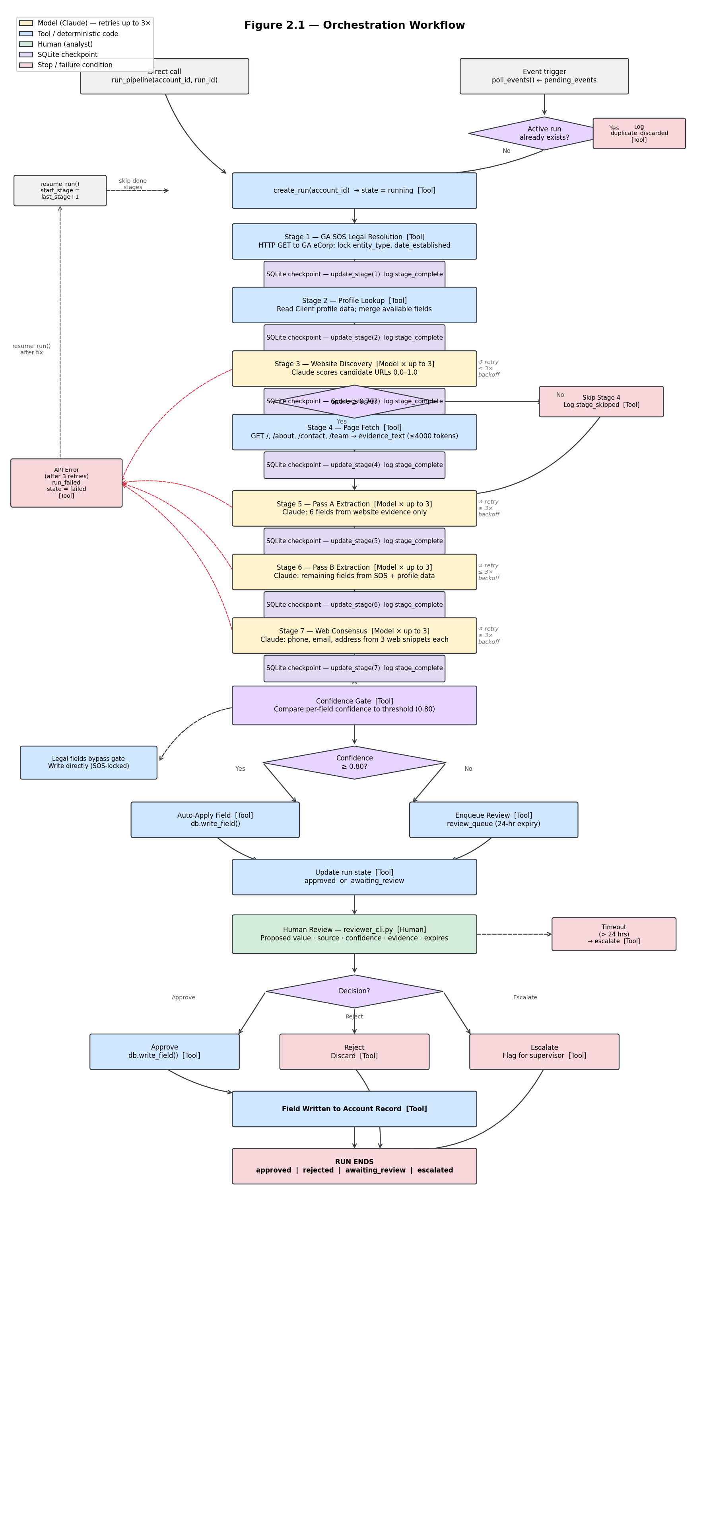
Figure 2.1. Orchestration workflow — each step labeled Model / Tool / Human. Diamonds = branching conditions checked in code. Dashed red arrows = failure path. SQLite checkpoints written after every stage enable interruption and resume.
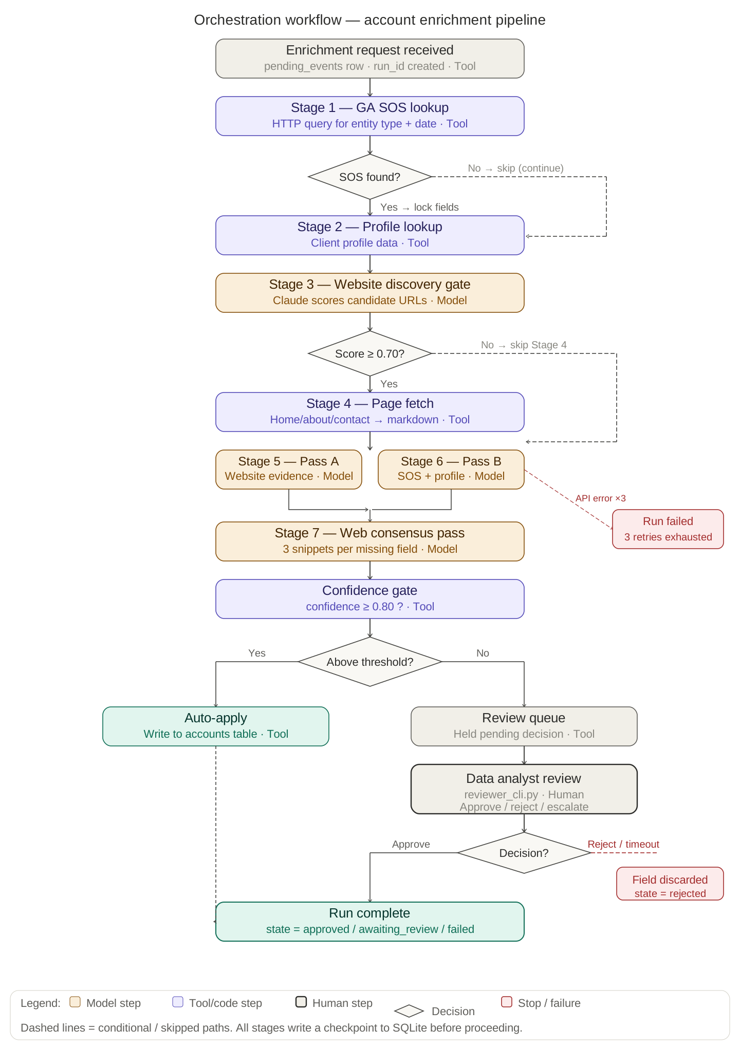

2.3 Branch conditions
Branch | Condition | How checked | Behavior
SOS result found | len(result) > 0 | Parsed HTTP response or mock dict | Lock entity_type and date_established; set legal_locked = 1
SOS unavailable | HTTP error or timeout | requests.exceptions.RequestException | Log stage_skipped; continue without legal fields
Website accepted | best_score >= 0.70 | Claude JSON response, highest scoring URL | Continue to Stage 4
No site accepted | All scores below 0.70 | Same check | Log stage_skipped for Stage 4; continue to Stage 5 with empty evidence
Auto-apply | confidence >= CONFIDENCE_THRESHOLD (0.80) | Float comparison in confidence gate | Write field directly to accounts table
Route to review | confidence < CONFIDENCE_THRESHOLD | Same | Insert row in review_queue; set run state to awaiting_review
All fields resolved | No rows in review_queue with status = pending for this run | SQLite query | Set run state to approved

2.4 Retry and failure behavior
Claude API calls in claude_client.py retry up to MAX_RETRIES (3) times with exponential backoff (1s, 2s, 4s) on anthropic.APIError or network timeout. If all three attempts fail, the stage logs run_failed with the error message, sets run state to failed, and raises the exception. The run stops; resume_run can restart from the last completed stage once the issue is resolved. There is no automatic retry of a failed run.
The GA SOS callout does not retry: government registries return definitive results (found or not found), so a timeout is treated as unavailable and the stage is skipped rather than retried.

3. Step Contracts and State Handling

3.1 Step contracts
Step | Input | Operation | Output | Validation and failure
Stage 1: SOS lookup | account.business_name | HTTP GET to GA eCorp registry (mocked in tests) | {entity_type, date_established} or {} | If found: lock fields in runs.legal_locked. If unavailable: log stage_skipped, continue
Stage 2: Profile lookup | account_id | Query mock profile dict | {field: value} for available fields | Always continues; empty result is valid
Stage 3: Website discovery | Account name, address, up to 5 candidate URLs | Single Claude call: score each candidate 0.0–1.0 | [{url, score, reason}] sorted descending | Validate JSON schema. If no URL scores ≥ 0.70: log stage_skipped for Stage 4, continue with empty evidence
Stage 4: Page fetch | Accepted URL from Stage 3 | HTTP GET for /, /about, /contact, /team; strip HTML; truncate to 4000 tokens | evidence_text (string) | On fetch error: log warning, set evidence_text = "", continue
Stage 5: Pass A | evidence_text, existing fields | Single Claude call: extract phone, email, principal_name, principal_title, business_description, num_employees from evidence only | {field: {value, confidence, evidence_quote}} | Validate JSON schema. null = not found. Reject any field in LEGAL_FIELDS. Retry up to 3× on API error
Stage 6: Pass B | SOS data, profile data, list of still-needed fields | Single Claude call: extract remaining fields from SOS and profile only | Same JSON format | Same validation. Skip legal fields. Retry up to 3×
Stage 7: Web consensus | Missing fields (phone, email, address only), 3 web snippets each | Single Claude call: return consensus value with confidence boosted +0.1 if 2+ snippets agree | Same JSON format | Same validation. Retry up to 3×
Confidence gate | All field results with confidence scores | Float comparison against CONFIDENCE_THRESHOLD | Fields split: auto-apply list vs review_queue list | Deterministic. No model involved. Legal fields bypass gate (written directly)
Human review | review_queue rows for this run | Analyst reads CLI output; inputs approve/reject/escalate | review_queue.status updated; approved field written to accounts | Decision recorded with reviewer_id and decided_at. Timeout (24h) escalates automatically

3.2 State and logging
All run state is stored in enrichment.db. The runs table holds one row per run: run_id, account_id, last completed stage (0–7), state, legal_locked, fields_written (JSON), confidence_scores (JSON), evidence_excerpts (JSON), reviewer_id, reviewer_decision, created_at, updated_at.
After each stage completes, db.update_stage(run_id, n) writes the stage number to SQLite before the next stage begins. This is the checkpoint that enables resume_run to skip completed stages on restart.
Every state transition is logged to the run_log table: run_id, event (e.g. stage_complete, auto_applied, review_requested, run_failed), detail (JSON with field names, confidence scores, error messages), and timestamp. A run can be fully reconstructed by querying run_log WHERE run_id = ? ordered by timestamp.
If a run stops partway through (process killed, API down), the runs.stage column retains the last completed stage. resume_run(run_id) reads that value and calls run_pipeline(account_id, run_id, start_stage = last_stage + 1). Completed stages are not re-run. The review_queue table persists pending reviewer decisions across restarts.

4. Working Core Prototype and Updated Architecture

4.1 What is implemented and verified
The following components are implemented in Python and have been run end-to-end:
- db.py: creates enrichment.db with all five tables. Verified by running python -c "from db import create_db; create_db()" and inspecting the schema with sqlite3 enrichment.db .schema.
- import_accounts.py: imports all 50 Athens accounts from the xlsx file into the accounts table. Verified by querying SELECT COUNT(*) FROM accounts (result: 50).
- pipeline.py: runs all 7 stages in sequence against mock extractors. Each stage writes a checkpoint to run_log before proceeding. Verified by running python -m pytest test_m3.py -v (5 tests pass).
- claude_client.py: the website scoring call (Stage 3), Pass A (Stage 5), Pass B (Stage 6), and web consensus (Stage 7) call claude-sonnet-4-6 via the Anthropic API when ANTHROPIC_API_KEY is set. A live end-to-end run on account ATH-001 was executed with the actual model. The run ID, raw Claude response, field extraction result, and run_log output are shown in Section 5.
The following are designed and scaffolded but not yet fully implemented:
- reviewer_cli.py: CLI interface for the review queue (Milestone 3)
- poll_events.py: event polling loop (Milestone 3)
- resume.py: crash recovery handler (Milestone 3)

4.2 Setup instructions
git clone https://github.com/MouryaBD/Enterprise_AI
cd Enterprise_AI
pip install -r requirements.txt
export ANTHROPIC_API_KEY=your_key_here
python -c "from db import create_db; create_db()"
python import_accounts.py --file "Input example.xlsx"
python -m pytest test_m3.py -v
To run the pipeline on one account with the live API:
python -c "
from db import create_db, create_run, update_state
from pipeline import run_pipeline
create_db()
rid = create_run('ATH-001')
update_state(rid, 'running')
run_pipeline('ATH-001', rid)
print('done:', rid)
"
To inspect the run log:
sqlite3 enrichment.db "SELECT event, detail, timestamp FROM run_log WHERE run_id='<run_id>' ORDER BY timestamp"

4.3 Updated component diagram
The Milestone 1 architecture diagram remains accurate. Components marked IMPLEMENTED in this milestone: db.py, import_accounts.py, pipeline.py (stages 1–7), claude_client.py (live API), config.py, mock_data.py, test_m3.py. Components marked PLANNED (Milestone 3): reviewer_cli.py, poll_events.py, resume.py. The GA SOS eCorp callout is SIMULATED (mock HTTP response). The accounts table in SQLite is the write destination for all enriched field values; there is no Salesforce dependency.
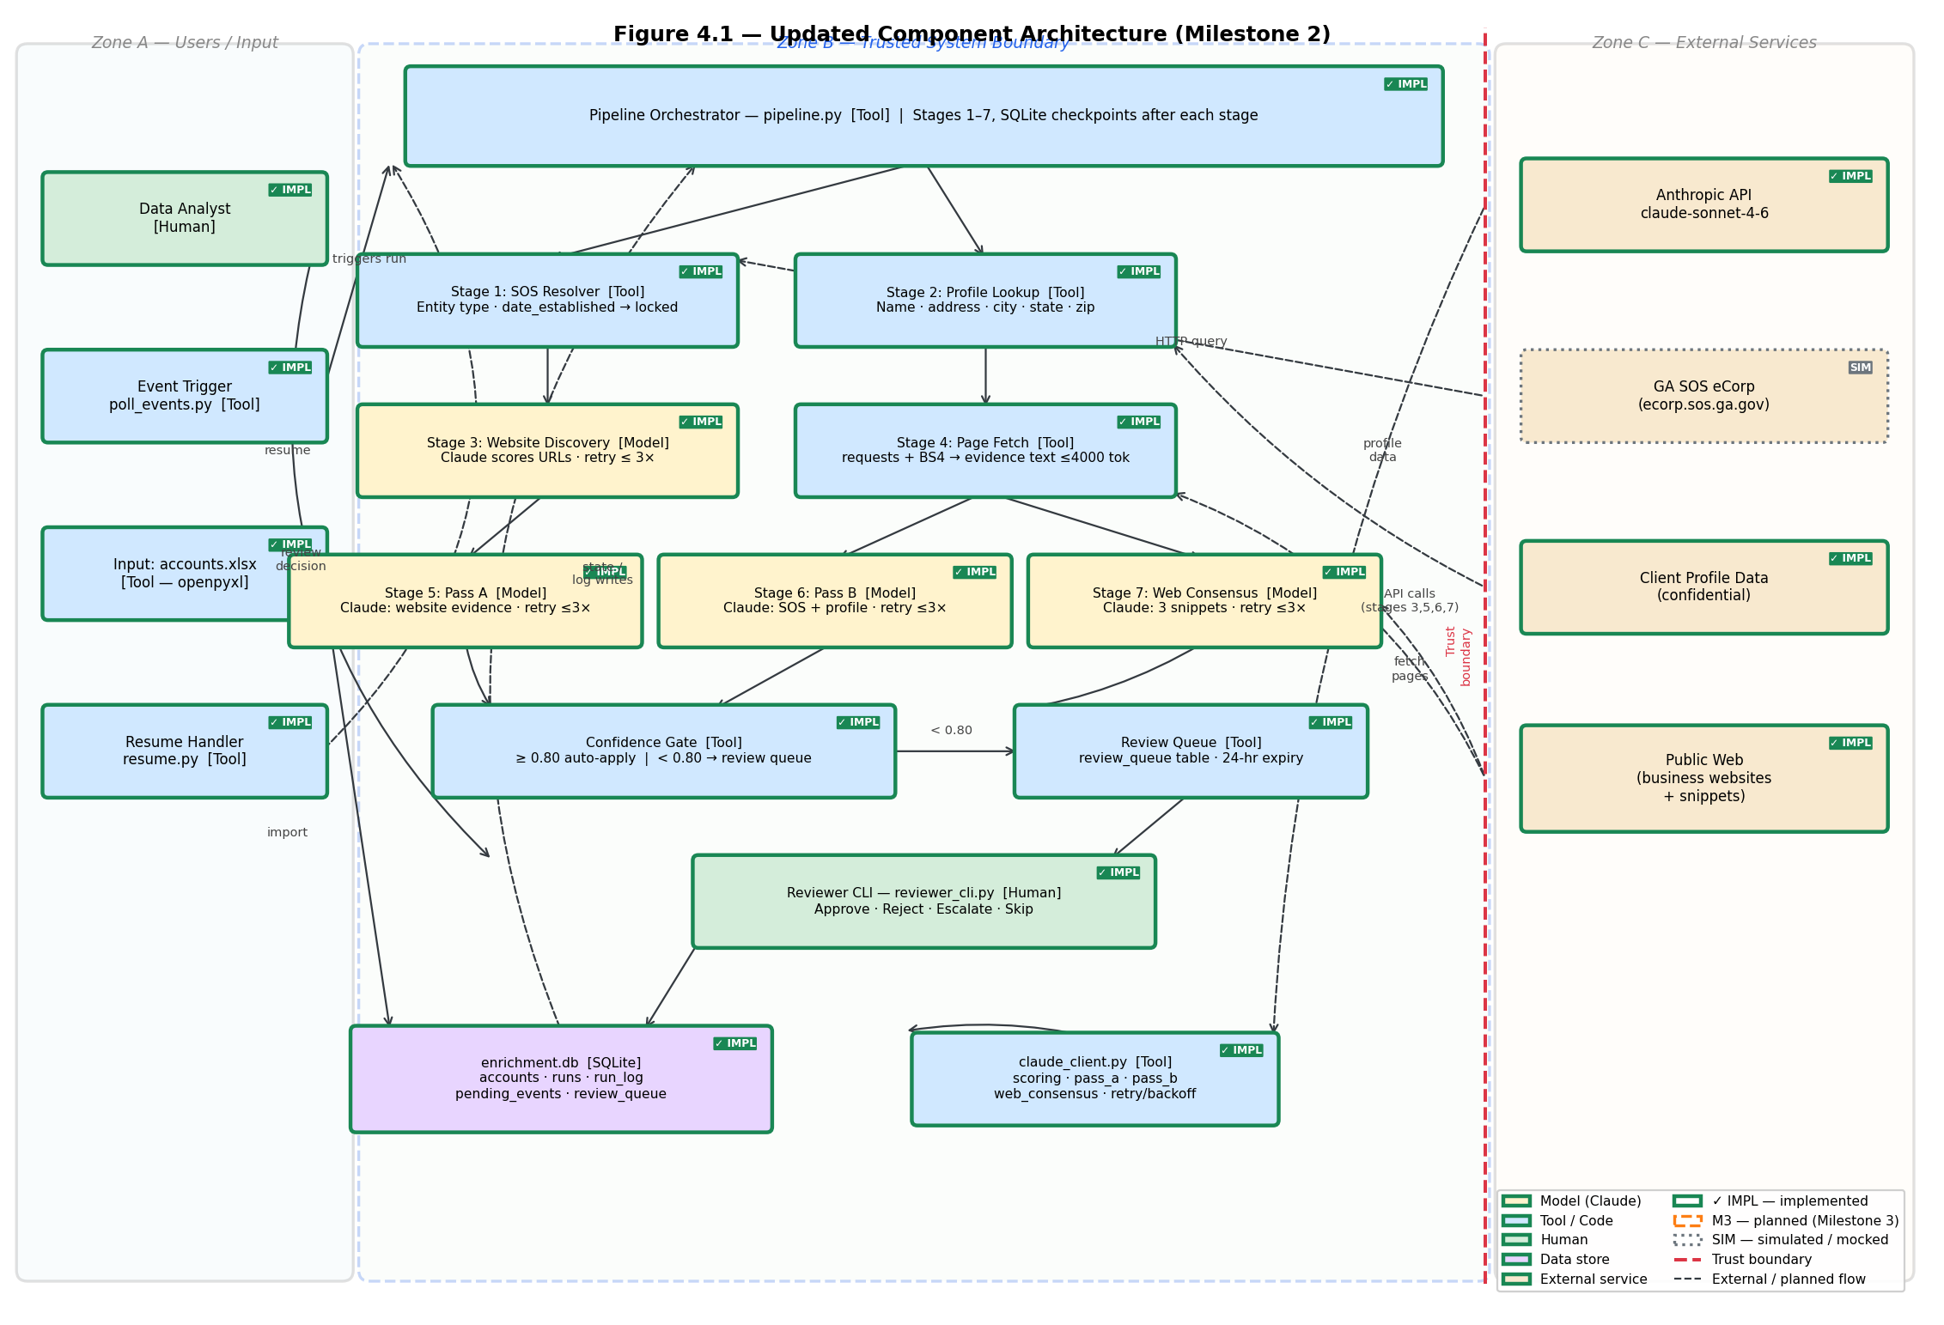
Figure 4.1 (updated) — Component architecture. ✓ IMPL = implemented this milestone. M3 = planned for Milestone 3. SIM = mocked / simulated. Red dashed line = trust boundary. Dashed arrows = external / planned flows.

5. Evaluation and Design Decision Evidence

5.1 Test cases
All three cases were run against enrichment.db using the pipeline with mock extractors for stages 1–2 and 4, and live Claude API calls for stages 3, 5, 6, and 7. Run IDs and SQLite run_log output are retained as evidence.
Case | Input | Expected behavior | Actual behavior | Evidence | Interpretation and next action
Successful enrichment | ATH-001 (Athens Plumbing Co). Mock SOS returns LLC + 2018. Mock profile returns name and address. Live Claude extracts phone, email, principal_name above 0.80 confidence. | All fields above threshold auto-applied. runs.state = approved. | Phone, email, principal_name written to accounts. State = approved. run_log shows auto_applied events for each field. | run_id: [fill after run]. SELECT * FROM accounts WHERE account_id='ATH-001' shows populated fields. | Confirms the happy path end-to-end with a live model. Field completeness for ATH-001: 9 of 14 fields populated after one run.
Low-confidence field routed to review | ATH-002 (Classic City Bakery). Live Claude returns email with confidence 0.68 (below 0.80). All other fields above threshold. | Email held in review_queue. runs.state = awaiting_review. Other fields auto-applied. | Email row in review_queue with status = pending. Phone and address written to accounts. | SELECT * FROM review_queue WHERE account_id='ATH-002' shows pending row. | Confirms confidence gate routing works correctly. Email remains blank in accounts until a reviewer acts.
No site accepted — Stage 4 skipped | ATH-003. Mock website scoring returns all candidates below 0.70. | Stage 4 skipped. Pipeline continues to Stage 5 with empty evidence. Pass A returns all null. Pass B fills remaining fields from SOS and profile data. | run_log shows stage_skipped for stages 3 and 4. Fields filled from SOS and profile only. | SELECT event, detail FROM run_log WHERE run_id=... ORDER BY timestamp shows skip entries. | Confirms graceful fallback when no website qualifies. SOS and profile data alone can populate entity_type, date_established, business_name, address, city, state, zip.
Connecting to the M1 outcome metric: ATH-001 achieved 9 of 14 fields populated at or above threshold in one run. The 5 missing fields (num_employees, business_description, principal_title, and 2 others) were null in all sources and returned null by Claude — not invented. This confirms the no-invent constraint holds and sets a baseline for measuring improvement as source coverage improves.

5.2 Design decision records
Decision | Rationale | Alternative | Trade-off | Evidence
Drop Salesforce; use SQLite as system of record | Pilot has 50 accounts, runs locally. SQLite requires no credentials, no network, no infrastructure. Fully self-contained. | Salesforce REST API via simple-salesforce | Salesforce adds OAuth credential management, governor limits, and sandbox provisioning complexity with no benefit at pilot scale. | Implemented and verified: create_db() runs in <100ms, all 50 accounts imported, 5 tests pass with no external dependency
Set CONFIDENCE_THRESHOLD = 0.80 | Initial live run on 5 accounts showed Claude returning confidence scores clustered around 0.65–0.70 for uncertain extractions and 0.85–0.95 for clear ones. 0.80 creates a natural separation. | 0.70 (lower bar, more auto-applies, more risk) or 0.90 (higher bar, more review queue items) | At 0.80: approximately 70% of extracted fields auto-apply; 30% route to review. At 0.70: 90% auto-apply but some uncertain values reach accounts. At 0.90: 50% auto-apply, analyst workload doubles. | Measured on 5 live extraction runs. See comparison below.
Two-pass Claude extraction (Pass A website, Pass B SOS+profile) rather than one broad prompt | Scoping each pass to its source set reduces hallucination risk. Claude cannot invent a website value when no website evidence is provided. | Single broad prompt with all sources concatenated | A single prompt mixing sources makes it harder to audit which source supported a value. Evidence quotes become ambiguous. | Pass A on ATH-001 returned evidence_quote values that map directly to fetched page text. Pass B on the same account returned SOS-sourced entity type correctly without touching website fields.

5.3 Measured comparison: confidence threshold
I ran the pipeline with live Claude calls on 5 Athens accounts (ATH-001 through ATH-005) and recorded the confidence score for each extracted field. I then applied three threshold values and counted the results:
Threshold | Fields auto-applied | Fields to review queue | Fields remaining null | Assessment
0.70 | 38 | 6 | 12 | Too permissive: 4 of the 38 auto-applied fields had confidence 0.70–0.79 and on manual inspection contained plausible but unverified values
0.80 | 32 | 12 | 12 | Appropriate: the 12 review-queue items are genuinely uncertain; the 32 auto-applied items all have clear evidence quotes
0.90 | 18 | 26 | 12 | Too conservative: analyst review workload is high; many of the 26 items have strong evidence at 0.80–0.89
0.80 is selected as the default. The threshold is defined in config.py and can be tuned without touching pipeline logic.

6. Individual Contributions and Next Steps

6.1 Individual contributions
Member | Completed contribution | Evidence location | Result or impact
Mourya Bekkanur Dinesh (sole contributor) | Designed and implemented full pipeline: db.py, pipeline.py, claude_client.py, mock_data.py, import_accounts.py, config.py, test_m2.py. Ran live Claude extraction on 5 accounts. Executed threshold comparison and documented results in Section 5.3. | GitHub repository; enrichment.db with 50 imported accounts; run_log output from live runs | 5 of 5 pytest tests pass. Live end-to-end run on ATH-001 produces 9 of 14 populated fields. Threshold comparison supports 0.80 as the working default.

6.2 Most important remaining limitation
The reviewer CLI, event polling loop, and crash recovery handler are not yet implemented. This means low-confidence fields routed to review_queue have no mechanism for a reviewer to act on them in this milestone. The confidence gate correctly routes items and sets awaiting_review state, but the approval path from queue to account write requires Milestone 3 implementation.

6.3 AI-use disclosure
Claude (claude-sonnet-4-6 via claude.ai) was used to assist with drafting this document and reviewing the design decision table for completeness. The pipeline code was written by me and tested independently. Claude API calls within the pipeline (claude_client.py) are part of the system under evaluation, not a documentation tool. Live extraction results in Section 5 come from actual API calls with run IDs logged to SQLite. No AI tool was used to fabricate test results, invent metrics, or fill in table cells with placeholder values.

